Scalable & Secure 3-Tier Architecture on AWS
- Objective: -
A 3-tier architecture on AWS is a cloud infrastructure design that separates an application into three independent layers: Web Tier, Application Tier, and Database Tier. This architecture improves security, scalability, availability, and maintainability.

Core Infrastructure Component Stack: -
Networking: Amazon VPC, Public & Private Subnets, Internet Gateway, NAT Gateway, Elastic IPs.
Compute: Amazon EC2 (Presentation & Application layers), Auto Scaling Groups.
Database: Amazon RDS (MySQL Engine).
Traffic Management: Public (Internet-Facing) and Internal Application Load Balancers (ALB).

- Diagram Of Architect: -

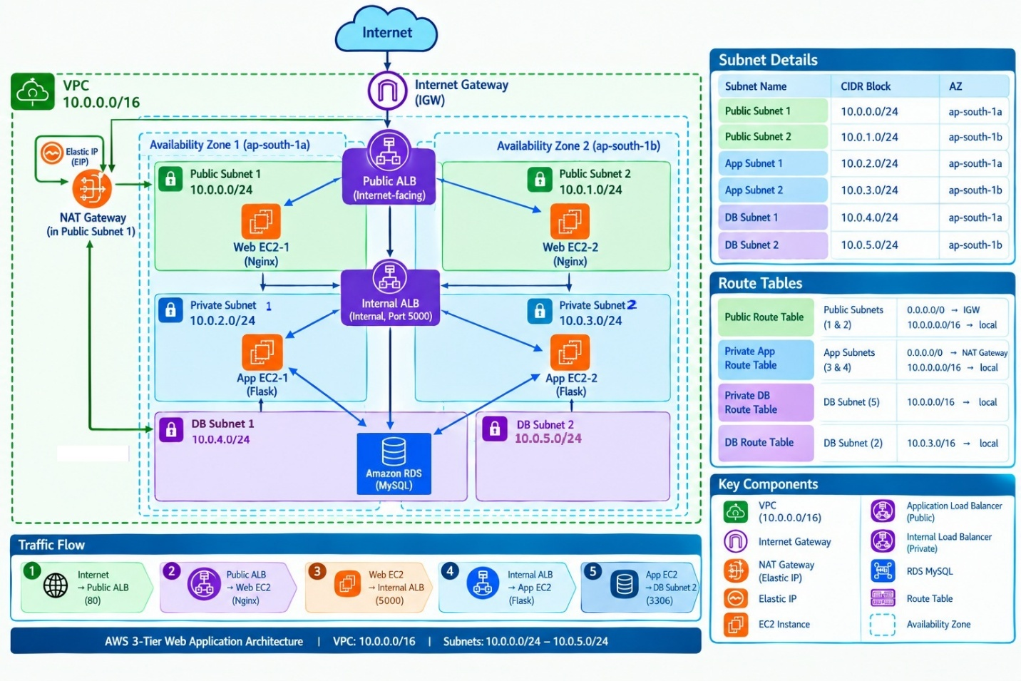
Traffic Flow Design:-
